1. **Supplier evaluation email** in **RFQ Supplier Maintenance Table** must not be blank or null for those suppliers that need to be available in the supplier evaluation module. REQUEST FOR QUOTATION > Supplier > Find supplier then click EDIT link.

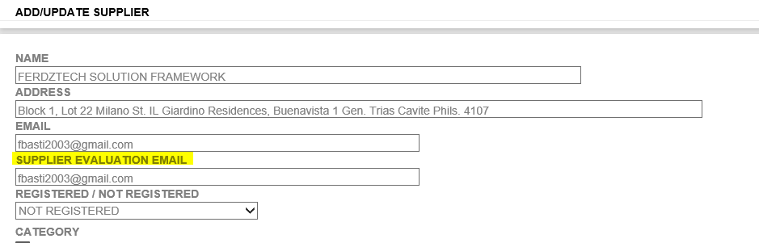

1. Make sure that you have added Fiscal Year that you want to use for your current evaluation. SUPPLIER EVALUATION > Fiscal Year then click Add New link. Click EDIT link if you want to update then click SAVE.

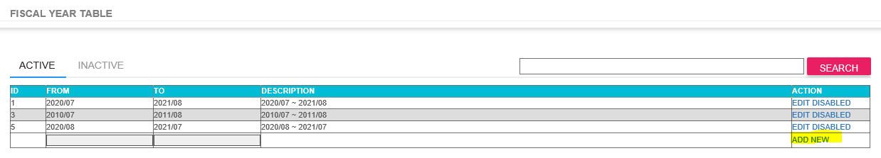

1. Make sure that Evaluation Criteria for Maker is taking in place. SUPPLIER EVALUATION > Evaluation Criteria (For Maker) then click Add New link. Click EDIT link if you want to update then click SAVE.

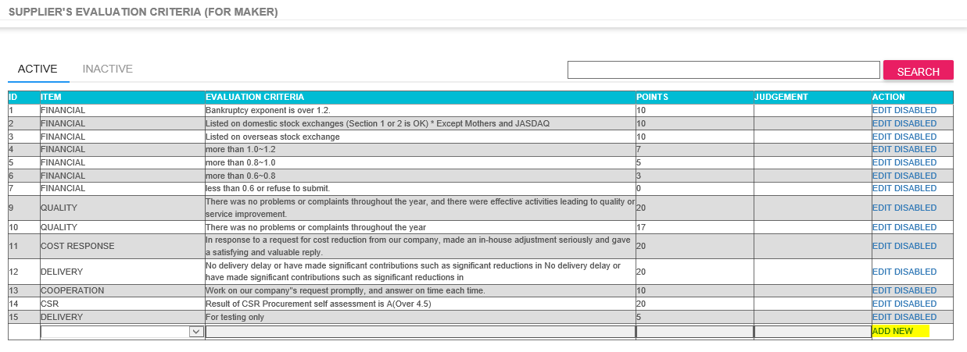

1. Make sure that Evaluation Criteria for Trader is taking in place. SUPPLIER EVALUATION > Evaluation Criteria (For Trader) then click Add New link. Click EDIT link if you want to update then click SAVE.

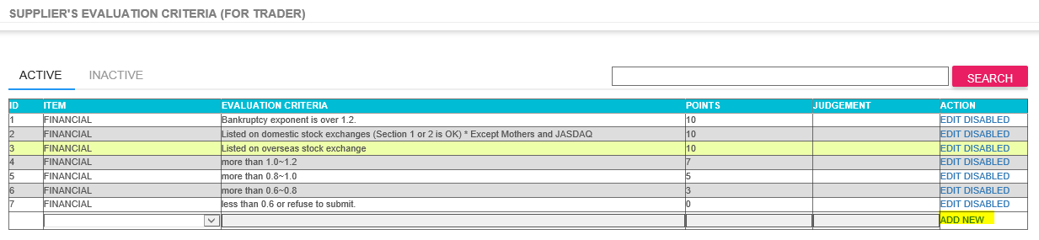

1. Make sure that Quality Evaluation Criteria is taking in place. SUPPLIER EVALUATION > Quality Evaluation Criteria then click Add New link. Click EDIT link if you want to update then click SAVE.

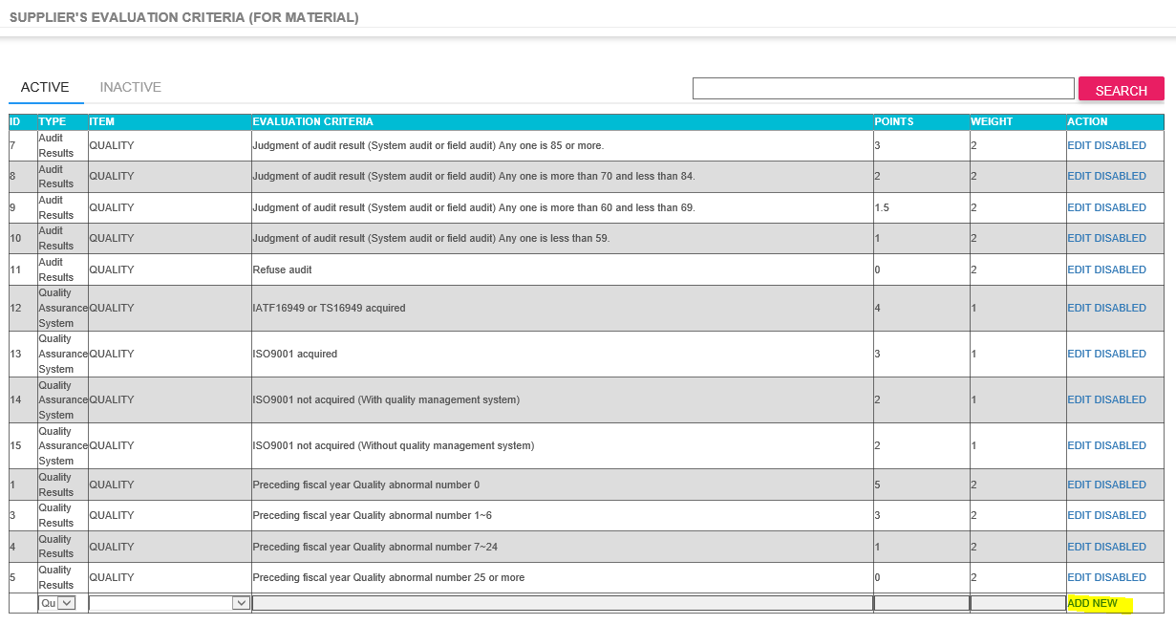

1. To create a new request, select SUPPLIER EVALUATION > Evaluation Request Entry. Then, you can see available suppliers in the list. These suppliers are with those **Supplier evaluation email** in **RFQ Supplier Maintenance Table.** Make sure that you selected the correct fiscal year that you want to use. By default, status “SEND?” is check and ready for sending and you can uncheck it if you think that supplier is not included and it will change the status to “NOT FOR SENDING”.

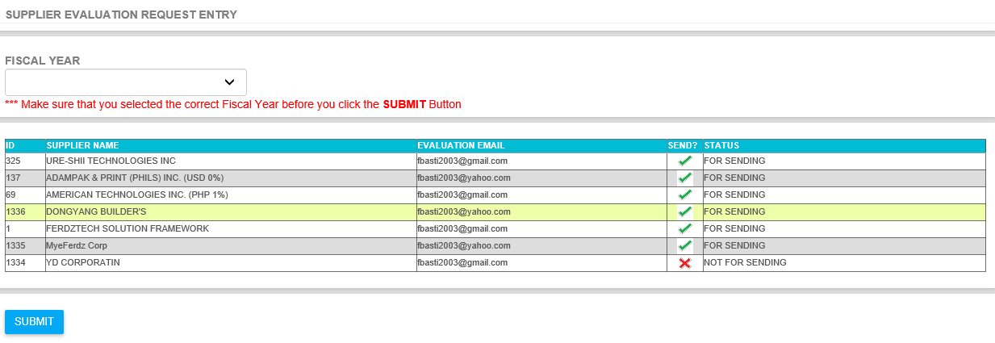

After you selected the fiscal year and selected all needed suppliers then click the submit button and a reminder box will appear.

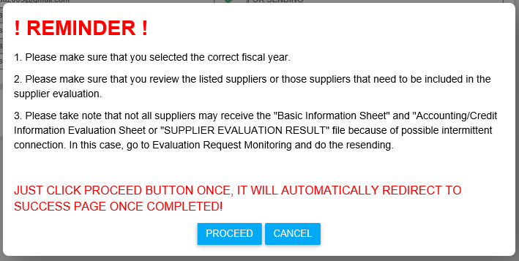

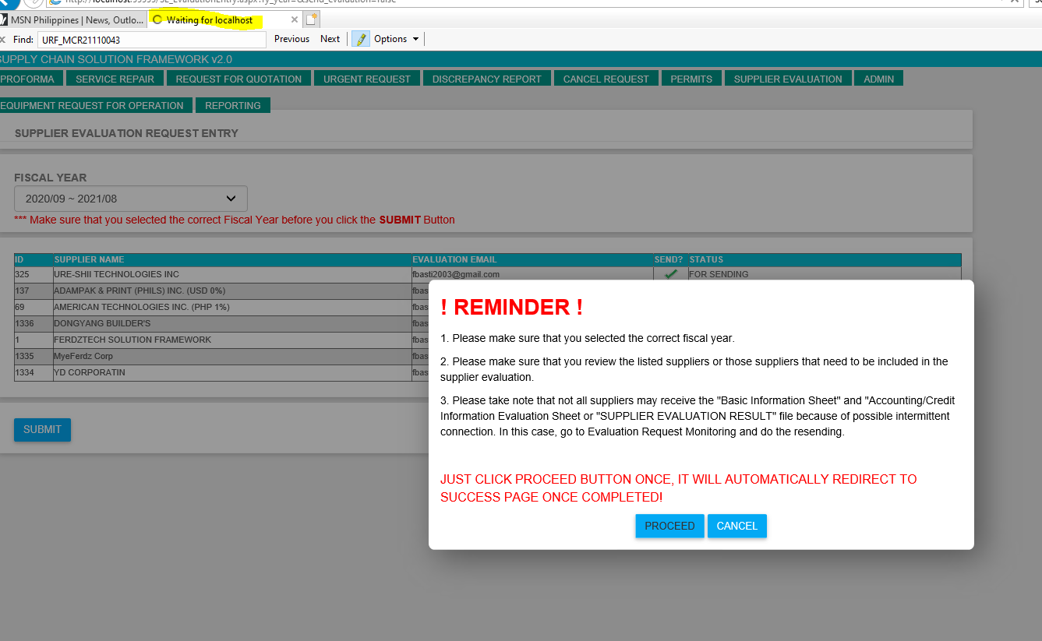

After clicking PROCEED button you will see the page title “Waiting”. After the process completion it will automatically redirect to success page.

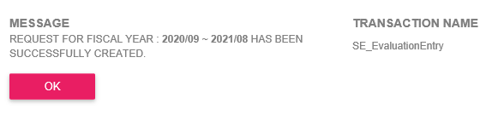

1. After the submission you can check your request status in SUPPLIER EVALUATION > Evaluation Request Monitoring. When you click the fiscal year this will redirect to page were you can check the detailed status of the supplier responses.

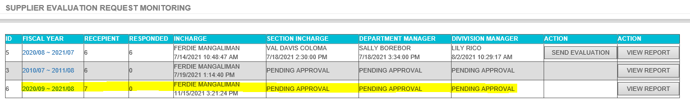

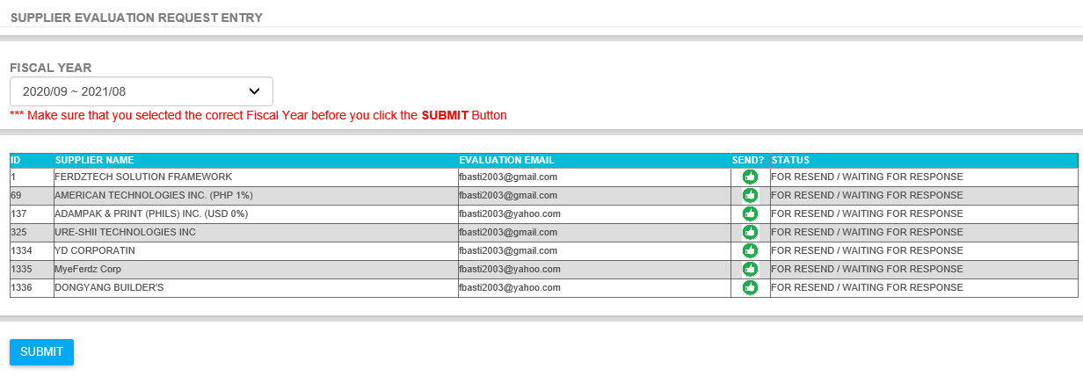

Below are the example emails sent to Suppliers.

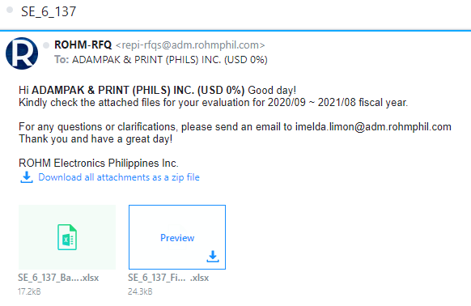

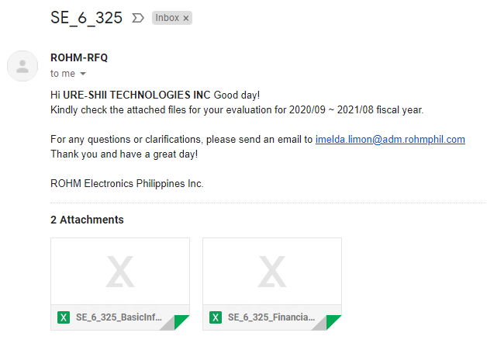

1. SUPPLIER EVALUTION > Supplier Evaluation Table. This is the table were you able to update all the supplier evaluation fields. Once you updated all the suppliers the “SEND FOR APPROVAL” button will appear to send it to the next approver. Please take note that you are only allowed to update all records up until the transaction has not yet posted.

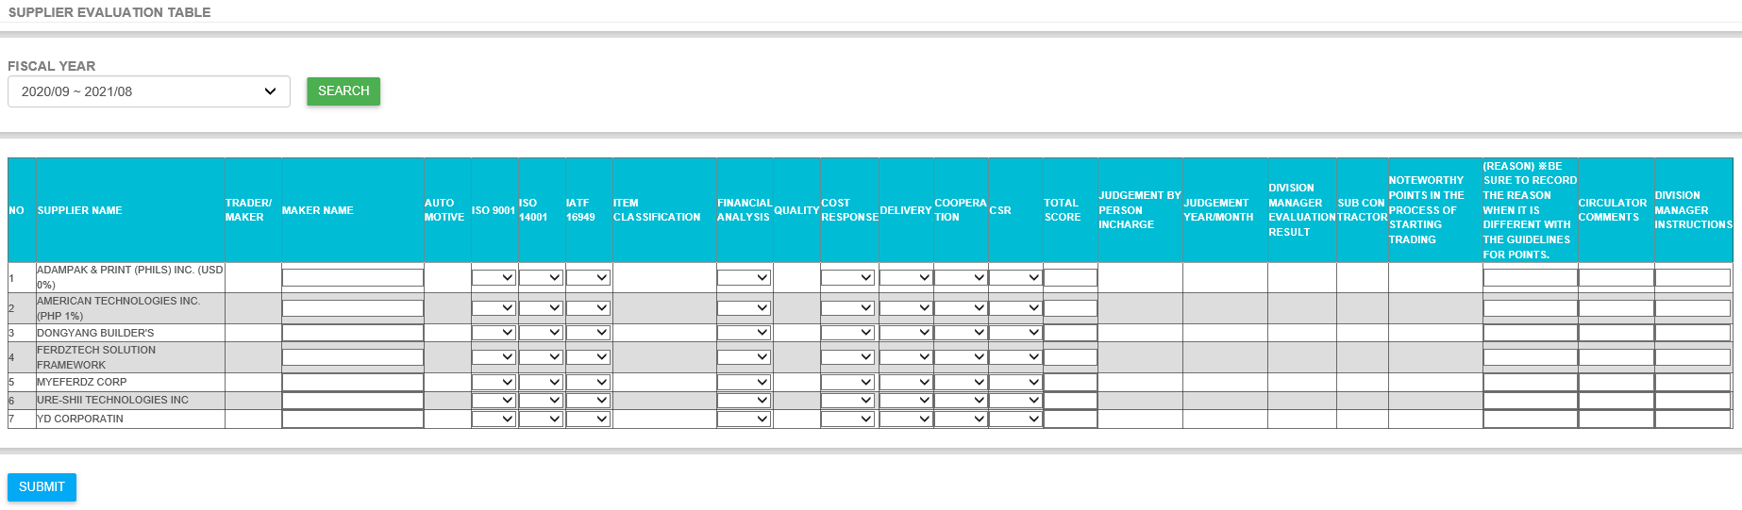9. SUPPLIER EVALUATION > Supplier Evaluation Approval. Approver can select the fiscal year that he/she want to approve. Details will appear when you click the fiscal year link in the FISCAL YEAR column.

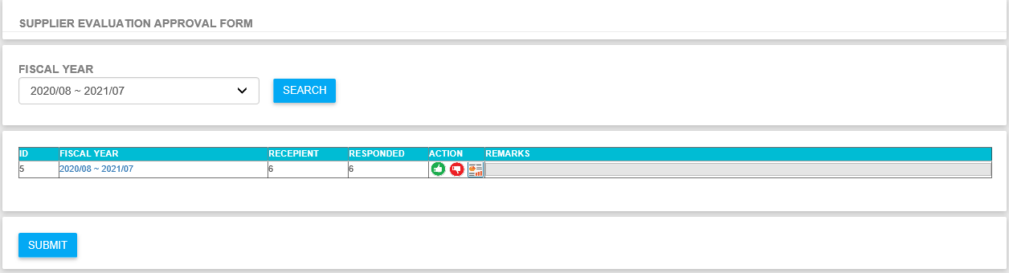

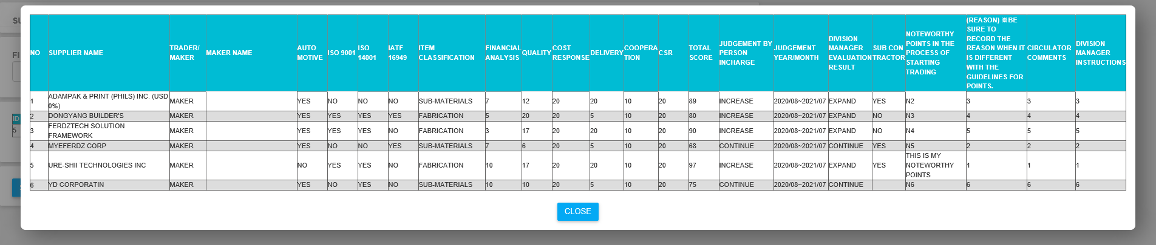

1. Once all are approved then the Supplier Evaluation Result will now send to suppliers. SUPPLIER EVALUATION > Evaluation Request Monitoring then click SEND EVALUATION button and again the default reminder will appear. Please note that the SEND EVALUATION button will appear once the Division Manager approved the request.

